**[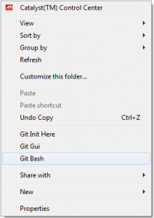](http://www.tutorial-webdesign.com/wp-content/uploads/2013/05/git-bash.png)**